Integrating the Healthcare Enterprise

IHE RO
Technical Framework Supplement

Deformable Registration in Radiation Oncology
(DRRO)

Revision 0.10 – Draft in Preparation for Public Comment
<The IHE Documentation Specialist will change the title to just “Draft for Public Comment” upon publication for public comment; leave “as is” until then.>

Date: <Month xx, 20xx>
Author: <Author Name or Technical Committee Name>
Email: <domain_name@ihe.net>
<Instructions to authors are encapsulated in angled brackets as “< … >” and denoted with italicized text. These instructions are to be deleted in their entirety prior to publication.>
<Use of capitalization: Please follow standard English grammar rules-only proper nouns and names are upper case. For example, “Modality Actor” is upper case, but “an actor which fulfills the role of a modality” is lower case. Do not use upper case to emphasize a word/topic.>
<Note: There are editing conventions, such as diagram numbering and how to use Microsoft Word tools, etc., at http://wiki.ihe.net/index.php?title=Writing_Technical_Frameworks_and_Supplements. Please review this prior to beginning a new Supplement. This is especially useful for first time authors.>
<This Supplement Template is intended for the development of new Profiles or for making significant changes to Profiles, such as adding formal Options. Simple changes to existing Supplements or Profiles should be made using the Change Proposal (CP) process. See the Technical Framework Development section at http://wiki.ihe.net/index.php?title=Process#Technical_Framework_Development for more guidance on Supplements vs. CPs.>
<All of the sections in this document are required. Sections may not be deleted. The outline numbering is intended to be consistent across Profiles and across Domains, so do not adjust the outline numbering. If there is no relevant content for a section, simply state “Section not applicable”, but leave the numbering intact. Sub-sections may be added for clarity.>
<This Supplement Template includes templates for Volumes 1 (Profiles), 2 (Transactions), 3 (Content Modules), and 4 (National Extensions).>
<Volumes 1, 2, and/or 3 are developed together for Public Comment and Trial Implementation submission. Volume 4, National Extensions, is typically developed at a later point in time, usually at Trial Implementation or later. Templates for all four volumes are included in this document for the sake of completeness. If you are beginning a new profile, you are strongly discouraged from using National Extensions and should instead focus on optional data sets or other alternatives. For more information, see http://wiki.ihe.net/index.php?title=National_Extensions_Process.>
Foreword
This is a supplement to the IHE <Domain Name> Technical Framework <VX.X>. Each supplement undergoes a process of public comment and trial implementation before being incorporated into the volumes of the Technical Frameworks.
<For Public Comment:> This supplement is published on <Month XX, 201x> for Public Comment. Comments are invited and may be submitted at http://www.ihe.net/<domain>/<domain>comments.cfm. In order to be considered in development of the Trial Implementation version of the supplement, comments must be received by <Month XX, 201X>.
<For Trial Implementation:> This supplement is published on <Month XX, 201X> for Trial Implementation and may be available for testing at subsequent IHE Connectathons. The supplement may be amended based on the results of testing. Following successful testing it will be incorporated into the <Domain Name> Technical Framework. Comments are invited and may be submitted at http://www.ihe.net/<domain>/<domain>comments.cfm.
This supplement describes changes to the existing technical framework documents.
“Boxed” instructions like the sample below indicate to the Volume Editor how to integrate the relevant section(s) into the relevant Technical Framework volume.
Amend section X.X by the following:
Where the amendment adds text, make the added text bold underline. Where the amendment removes text, make the removed text bold strikethrough. When entire new sections are added, introduce with editor’s instructions to “add new text” or similar, which for readability are not bolded or underlined.

General information about IHE can be found at: www.ihe.net.
Information about the IHE <Domain Name> domain can be found at: http://www.ihe.net/Domains/index.cfm.
Information about the organization of IHE Technical Frameworks and Supplements and the process used to create them can be found at: http://www.ihe.net/About/process.cfm and http://www.ihe.net/profiles/index.cfm.
The current version of the IHE <Domain name>Technical Framework can be found at: http://www.ihe.net/Technical_Framework/index.cfm.
<Comments may be submitted on IHE Technical Framework templates any time at http://ihe.net/ihetemplates.cfm. Please enter comments/issues as soon as they are found. Do not wait until a future review cycle is announced.

CONTENTS

Open Issues and Questions 6
Closed Issues 6
Appendix A – Actor Descriptions 7
Appendix B – Transactions 7
X.1.1 Actor Description and Actor Profile Requirements 12
X.4.1 15
Concepts 15
X.4.1.1 Deformable Image Registration (DIR) 15
X.4.1.2 Rigid transform and deformation vector field 15
X.4.1.3 16
Deforming Images, Contours and Dose 16
X.4.2 16
Use Cases 16
X.4.2.1 16
Use Case #1: Deformable Registration Creation 16
X.4.2.1.1 Deformable Registration Creation Use Case Description 16
X.4.2.2 Use Case #2: (Multimodality) Contouring I 17
X.4.2.2.1 (Multimodality) Contouring I Use Case Description 17
X.4.2.3 Use Case #3: (Multimodality) Contouring II 17
X.4.2.3.1 (Multimodality) Contouring II Use Case Description 17
X.4.2.4 Use Case #4: Dose Deformation 18
X.4.2.4.1 Dose Deformation Use Case Description 18
X.4.2.5 18
Use Case #5: Image Deformation 18
X.4.2.5.1 Image Deformation Use Case Description 18
X.4.2.6 19
Use Case #6: Image Distortion Correction 19
X.4.2.6.1 Image Distortion Correction Use Case Description 19
X.4.2.7 19
Use Case #Y: Extras 19
3.X Deformable Registration Storage [RO-DRRO-1] 22
3.X.1 Scope 22
3.X.2 Actor Roles 22
3.X.3 Referenced Standards 22
3.X.4 Messages 22
3.X.4.1 <Message 1 Name> 22
3.X.4.1.1 Trigger Events 22
3.X.4.1.2 Message Semantics 22
3.X.4.1.3 Expected Actions 22
3.Y Deformable Registration Retrieval [RO-DRRO-2] 22
3.Y.1 Scope 22
3.Y.2 Actor Roles 22
3.Y.3 Referenced Standards 22
3.Y.4 Messages 22
3.Y.4.1 <Message 1 Name> 22
3.Y.4.1.1 Trigger Events 22
3.Y.4.1.2 Message Semantics 22
3.Y.4.1.3 Expected Actions 22
7.3.X Deformable Spatial Registration IOD 24
7.3.X.1 Deformable Spatial Registration IOD for General Use 24
7.3.X.1.1 Deformable Spatial Registration IOD Base Content 24
7.3.X.1.2 Referenced Standards 24
7.3.X.1.3 IOD Definition 24
General Modules 25
7.4.1.7 25
Frame of Reference Module 25
7.4.1.7.1 25
Frame of Reference Module for Deformable Registrations 25
7.4.1.7.1.1 Reference Standards 25
7.4.1.7.1.2 Module Definition 25
7.4.1.8 General Image Module 25
7.4.1.8.X General Image Module in Deformed Image 25
7.4.1.8.X.1 Reference Standards 25
7.4.1.8.X.2 Module Definition 25
7.4.1.X General Reference Module 25
7.4.1.X.1 General Reference Module in Deformed Image 25
7.4.1.X.1.1 Referenced Standards 25
7.4.1.X.1.2 Module Definition 25
7.4.X Deformable Spatial Registration 26
Modules in Planning 26
7.4.X.1 Deformable Spatial Registration Module 26
7.4.X.1.1 Deformable Spatial Registration Module Base Content 26
7.4.X.1.1.1 Referenced Standards 26
7.4.X.1.1.2 Module Definition 26
7.4.13 Dose-Related Modules 27
7.4.13.3 RT Dose Module 27
7.4.13.3.2 RT Dose in Deformed Dose 27
7.4.13.3.2.1 Reference Standards 27
7.4.13.3.2.2 Module Definition 28

Introduction to this Supplement
The DRRO profile defines the content necessary for exchanging DICOM Deformable Spatial Registration (DSR) objects between radiation oncology systems. In addition to defining the data required to accomplish deformable image registration, it provides requirements on data elements so that DSR objects can be appropriately handled by radiation oncology systems that test to this profile.

Open Issues and Questions
# | Intr. in | Description
1 |  | Is there a usage for (0064,0010) Post Deformation Matrix?
2 |  | Use case “Dose compositor” partially overlaps with DCOM. The use case involves a Dose Actor and a Dose Compositor Actor. The latter is the same as in DCOM. Do we include this use case (as well the Dose Compositor Actor) in DRRO and how do we differentiate?  Include, but make sure that it is reflected in the resulting RT Dose.  2019-03-19: There appear to be some limitations in the current DICOM standard preventing storage with relevant references for the Deformable Dose Compositor.
3 |  | Should Use cases “Deformable registration creation” and “Deformable registration editing” be separate use cases or do we merge and use “optional” for consumption of Deformable Spatial Registration Object?  2018-02-04: Not clear if Use case “Deformable registration editing” corresponds to any current clinical product. The use case is retained as a placeholder.
4 |  | Contourer Actor is described as propagation of structures but for the use cases also used to describe the action of contouring in fusion view. Should we introduce one more actor (Fusion view contourer actor?)?
5 |  | Do we introduce prerequisites on the RT Dose objects considered (axial?)?
6 |  | 2019-03-18: Handling of Fiducial (0070,0314 “Used Fiducial Sequence”) was discussed. This is an Open Issue – could be handled as a Profile Option. The idea would be to use the reference structures (regions and/or points of interest) which have been used to guide the deformable registration algorithm.
7 |  | 2019-09-09: Deformable dose compositor actor and deformable compositing planning are moved to later versions of the profile.
8 |  | 2020-10-07: Patient Position in the case of PET should be discussed. Expression of patient position in PET is different than the historical way of expressing it in MR and CT. Check this profile and dependent profiles on patient position restrictions
9 |  | 2020-10-09: Are differences in orientation to gravity properly handled in DSRO and deformed images?
10 |  | 2020-10-09:  - Use cases not described above but which have been discussed:  - Use case: Deformable Registration Comparison  A device can display the differences between deformable registrations. The difference here between straight dose comparison is that it can accept the deformable registration and the data that composes it. The actors for this use case may not be different from actors suggested by other use cases (deformable dose compositing, displaying) except that it may have a comparison component and the ability to display deltas with side by side dose displays.  - Surgery Use Case: Resection Cavity Correction (Intra-Op Update)  - Any interest / relevance to add use case for diagnostic PET/CT planning CT contouring in fusion / contour propagation [deformable registration between diagnostic CT and planning CT, while diagnostic PET and planning CT used for fusion / propagation]?  - Resampling (images, structures, and dose) is outside the scope of the DRRO profile. This should be pointed out clearly in the description.

Closed Issues
<List the closed issues/questions with their resolutions. These are particularly useful for recording the rationale for closed issues to forestall unnecessary rehashing in the future and/or to make it easier to identify when a closed issue should be re-opened due to new information.>

<Note: The sections following this Introduction will eventually be added as Final Text to Volumes 1 – 4 of the Technical Framework. The material above this note (the Introduction, and Open and Closed Issues section) will be deleted when this Supplement is moved to Final Text.>

Appendix A – Actor Descriptions
Add the following new or modified actors to the IHE Technical Frameworks General Introduction Appendix A:
Deformable Registrator - A system that consumes multi-modality images and generates deformable registrations.
Deformable Displayer - A system that consumes multi-modality images, structure sets and deformable registrations to display the registered information. The producer of the deformable registration is expected to be a Deformable Registrator.
Contour Deformer - A system that consumes multi-modality images, structure sets and deformable registrations to generate deformed structure sets in a Deformable Displayer.
Dose Deformer - A system that consumes multi-modality images, structure sets, dose and deformable registrations to generate deformed dose objects in a Deformable Displayer.
Image Deformer - A system that consumes multi-modality images, structure sets, and deformable registrations to generate deformed images in a Deformable Displayer.

Appendix B – Transactions
Add the following new or modified transactions to the IHE Technical Frameworks General Introduction Appendix B:
- [RO-DRRO-1] Deformable Registration Storage: Storage of Deformable Registration Object instances.
- [RO-DRRO-2] Deformable Registration Retrieval: Retrieval of Deformable Registration Object instances.

Volume 1 – Profiles

X Deformable Registration for Radiation Oncology (DRRO) Profile
This Integration Profile specifies how images, RT Structure Sets, RT Doses, and associated deformable registration information can be exchanged, stored, processed, and displayed. The use of relevant DICOM objects (Deformable Spatial Registration) is clarified and constrained in order to avoid misinterpretations.
The Deformable Registration for Radiation Oncology (DRRO) Profile is a Workflow and Content Module profile. The focus is both on a registration workflow and content for image registration and deformation of structure sets and images.

X.1 DRRO Actors, Transactions, and Content Modules
Figure 1shows the actors directly involved in the DRRO Profile and the relevant transactions between them. If needed for context, other actors that may be indirectly involved due to their participation in other related profiles are shown in dotted lines. Actors which have a mandatory grouping are shown in conjoined boxes.

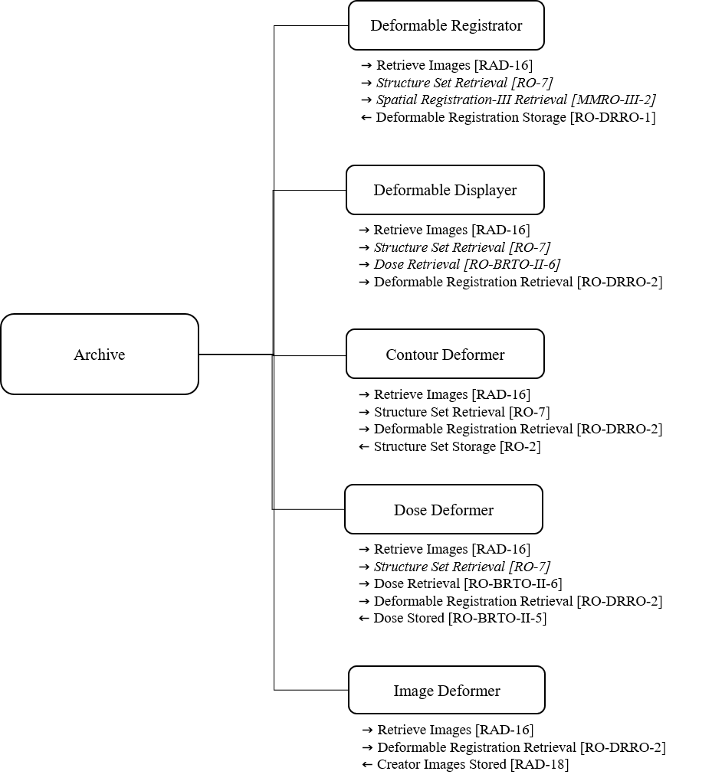
Figure X.1-1 DRRO Actor Diagram

Table 1 lists the transactions for each actor directly involved in the DRRO Profile. In order to claim support for this Profile, an implementation of an actor must perform the required transactions (labelled “R”) and may support the optional transactions (labeled “O”). Actor groupings are further described in Section XX.

Table X.1-1: DRRO Profile – Actors and Transactions
Actors | Transactions | Optionality | Reference
Deformable Registrator | Retrieve Images [RAD-16] | R | RAD TF-2: 4.16
 | Structure Set Retrieval [RO-7] | O | RO TF-2: 3.7
 | Spatial Registration-III Retrieval [MMRO-III-2] | O | RO TF-2: 3.18
 | Deformable Registration Storage [RO-DRRO-1] | R | RO TF-2: X.1
Deformable Displayer | Retrieve Images [RAD-16] | R | RAD TF-2: 4.16
 | Structure Set Retrieval [RO-7] | O | RO TF-2: 3.7
 | Dose Retrieval [RO-BRTO-II-6] | O | RO TF-2: 3.11
 | Deformable Registration Retrieval [RO-DRRO-2] | R | RO TF-2: X.2
Contour Deformer | Retrieve Images [RAD-16] | R | RAD TF-2: 4.16
 | Structure Set Retrieval [RO-7] | R | RO TF-2: 3.7
 | Deformable Registration Retrieval [RO-DRRO-2] | R | RO TF-2: X.2
 | Structure Set Storage [RO-2] | R | RO TF-2: 3.2
Image Deformer | Retrieve Images [RAD-16] | R | RAD TF-2: 4.8
 | Deformable Registration Retrieval [RO-DRRO-2] | R | RO TF-2: X.2
 | Creator Images Stored [RAD-18] | R | RAD TF-2: 4.18
Dose Deformer | Retrieve Images [RAD-16] | R | RAD TF-2: 4.16
 | Structure Set Retrieval [RO-7] | O | RO TF-2: 3.7
 | Dose Retrieval [RO-BRTO-II-6] | R | RO TF-2: 3.11
 | Deformable Registration Retrieval [RO-DRRO-2] | R | RO TF-2: X.2
 | Dose Stored [RO-BRTO-II-5] | R | RO TF-2: 3.3

Figure X.1-1 shows the actors directly involved in the DRRO Profile and the direction that the content is exchanged.
A product implementation using this profile may group actors from this profile with actors from a workflow or transport profile to be functional. The grouping of the content module described in this profile to specific actors is described in more detail in Cross Profile Considerations RO TF-1: X.6.
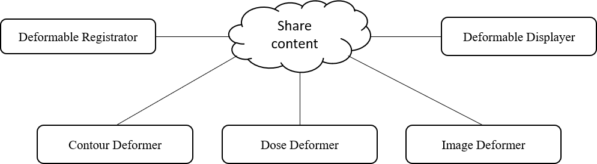
Figure X.1-2: DRRO Actor Diagram
Table 1-2 lists the content modules defined in the DRRO Profile. To claim support with this profile, an actor shall support all required content modules (labeled “R”) and may support optional content modules (labeled “O”).

Table X.1-2 DRRO – Actors and Content Modules
Actors | Content Modules | Optionality | Reference
Deformable Registrator | Deformable Spatial Registration IOD for General Use | R | RO TF-3: XX
 | Frame of Reference Module for Deformable Registrations | R | RO TF-3: XX
 | Deformable Spatial Registration Module Base Content | R | RO TF-3: XX
Deformable Displayer | - | - | -
Contour Deformer | - | - | -
Image Deformer | General Image Module in Deformed Image | R | RO TF-3: XX
 | General Reference Module in Deformed Image | R | RO TF-3: XX
Dose Deformer | RT Dose in Deformed Dose | R | RO TF-3: XX

X.1.1 Actor Description and Actor Profile Requirements

No additional requirements needed.

X.2 DRRO Actor Options
Options that may be selected for this Profile are listed in Table X.2-1 along with the Actors to which they apply. Dependencies between options when applicable are specified in notes.

Table X.2-1 DRRO – Actors and Options
Actor | Options | Reference
Deformable Registrator | Structure Set Retrieval [RO-7] | RO TF-2: 3.7
 | Spatial Registration-III Retrieval [MMRO-III-2] | RO TF-2: 3.18
Deformable Displayer | Structure Set Retrieval [RO-7] | RO TF-2: 3.7
 | Dose Retrieval [RO-BRTO-II-6] | RO TF-2: 3.11
Contour Deformer | No options defined | -
Image Deformer | No options defined | -
Dose Deformer | Structure Set Retrieval [RO-7] | RO TF-2: 3.7

X.3 DRRO Required Actor Groupings
None.

X.4 DRRO Overview

X.4.1

Concepts

X.4.1.1 Deformable Image Registration (DIR)
Deformable image registration (DIR) is the process of defining a mapping between the positions in one scan and their corresponding positions in another scan. This permits point-wise merging of information in scans acquired of the same subject at different time points or of different subjects and is of high relevance in many aspects of radiation therapy treatments.
DIR allows for alignment that accounts for changes such as organ deformation, patient weight loss, or tumor shrinkage. DIR has the perspective of being widely integrated into many different steps of the radiotherapy process including planning, delivery and accumulated dose from radiotherapy. For example, inter-fractional registration can be used to match an image acquired at one treatment fraction to an image from another fraction to improve patient positioning, and to evaluate organ motion relative to bony anatomy. Another particular use is data transfer between images to propagate contours from the planning images or from an atlas to newly acquired images as well as between images of different modalities. Intra-fractional registration is used to match images acquiring during a single treatment fraction. For example, this process is used to track respiratory motion and can be used to generate a model of organ motion across a patient population.
Once the registration is complete, the result is recorded in a Deformable Spatial Registration object which is typically stored in the study with the image data. The registration is described through a rigid transform, for initial coarse alignment, and a deformation vector field, for subsequent detailed alignment, see 4.1.2.
Many different deformable image registration algorithms exist. The specific algorithm used may be of interest to the user (especially when several different registrations exist between the same datasets). It is therefore relevant that the Deformable Spatial Registration object stores information on the type of algorithm used, for instance if the driving force is image information or fiducial markers in terms of POIs or ROIs.

X.4.1.2 Rigid transform and deformation vector field
Deformations and transformations describe how to sample data from the Source Reference Coordinate System (RCS) into the Registered RCS. The deformable spatial registration is applied to the Registered RCS coordinates by:
- First, transforming the coordinates using a pre deformation matrix; and
- Then, applying the deformation offsets to the resulting coordinates.
The resulting coordinate addresses the corresponding point within the Source RCS. In other words,
- Each vector describes the displacement of a point in the Registered RCS to spatially align with the corresponding point in the Source RCS, after having been rigidly aligned through a pre deformation matrix; and
- The vector field is defined on the Registered image.
Expressed as an equation, a source coordinate can be calculated as:
$\left[\begin{matrix}X_{Source} \\ Y_{Source} \\ Z_{Source} \\ 1\end{matrix}\right]=M_{pre}\left[\begin{matrix}X_{Start}+i∙X_{R} \\ Y_{Start}+i∙Y_{R} \\ Z_{Start}+i∙Z_{R} \\ 1\end{matrix}\right]+\left[\begin{matrix}∆X_{ijk} \\ ∆Y_{ijk} \\ ∆Z_{ijk} \\ 0\end{matrix}\right]$,
where ${\left(\begin{matrix}X & Y & Z\end{matrix}\right)}_{Source}$ is the spatial coordinate in the Source RCS; ${\left(\begin{matrix}X & Y & Z\end{matrix}\right)}_{Start}$ the start coordinate in the Registered RCS of the deformation grid; $\left(\begin{matrix}i & j & k\end{matrix}\right)$ the index in the deformation grid in the $X$, $Y$, and $Z$ dimension; ${\left(\begin{matrix}X & Y & Z\end{matrix}\right)}_{R}$ the resolution of the deformation grid in the $X$, $Y$, and $Z$ dimension; $\left(\begin{matrix}∆X_{ijk} & ∆Y_{ijk} & ∆Z_{ijk}\end{matrix}\right)$ the deformation at index $\left(i,j,k\right)$ in the deformation grid; and $M_{pre}$ the pre deformation matrix.

Note that a deformation vector field is not, in general, invertible. This is a difference with respect to Spatial Registration object which can be used for rigid alignment in both directions.

X.4.1.3

Deforming Images, Contours and Dose
A deformable image registration can be used to create deformed objects.
Contours on the Registered image can be deformed to the Source image following the vector field.
The Source image can be deformed to the Registered image and stored as a Deformed image. This allows for instance visualization of the two images fused.
A RT Dose defined on the Source image can be deformed to the Registered image and stored as a Deformed Dose. This allows for instance summation of doses on different images.

X.4.2

Use Cases

X.4.2.1

XSourceYSourceZSource1=MpreXStart+i∙XRYStart+i∙YRZStart+i∙ZR1+∆Xijk∆Yijk∆Zijk0

Use Case #1: Deformable Registration Creation
A deformable registration is created based on two images in the system.

X.4.2.1.1 Deformable Registration Creation Use Case Description
The Deformable Registrator and some data source (e.g. an Archive) retrieves data and stores a deformable registration.
Received:

  - Two series of images are retrieved.
  - Optional A structure set is retrieved.
- Action:
  - A deformable registration is created from Image R to Image S.
  - Structures (regions and points of interest) can optionally be used in the creation of the deformable registration
- Stored:
  - A Deformable Spatial Registration Object is stored.

X.4.2.1.2 Deformable Registration Creation Process Flow
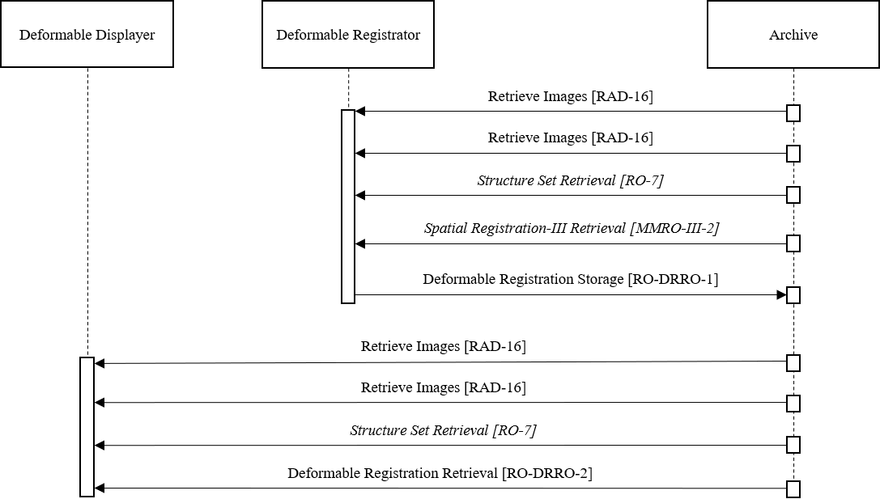
Figure X.4.2.1.2-1: Process Flow for Deformable Registration Creation

X.4.2.2 Use Case #2: Multimodality Contouring I
The images are visualized in a fusion view (based on the deformable image registration) and used to identify structures (regions and points of interest) in the system.

X.4.2.2.1 Multimodality Contouring I Use Case Description
- Received:
  - Two series of images (Image R and Image S) are retrieved.
  - A deformable registration from Image R to Image S is retrieved.
- Action:
  - Deformable Displayer displays a fusion of Image R and Image S using the deformable registration.
  - Deformable Displayer allows identification of structures (regions and points of interests) in the fusion view.

- Stored:
  - The structures in Image R are stored.

X.4.2.2.2 Multimodality Contouring I Process Flow
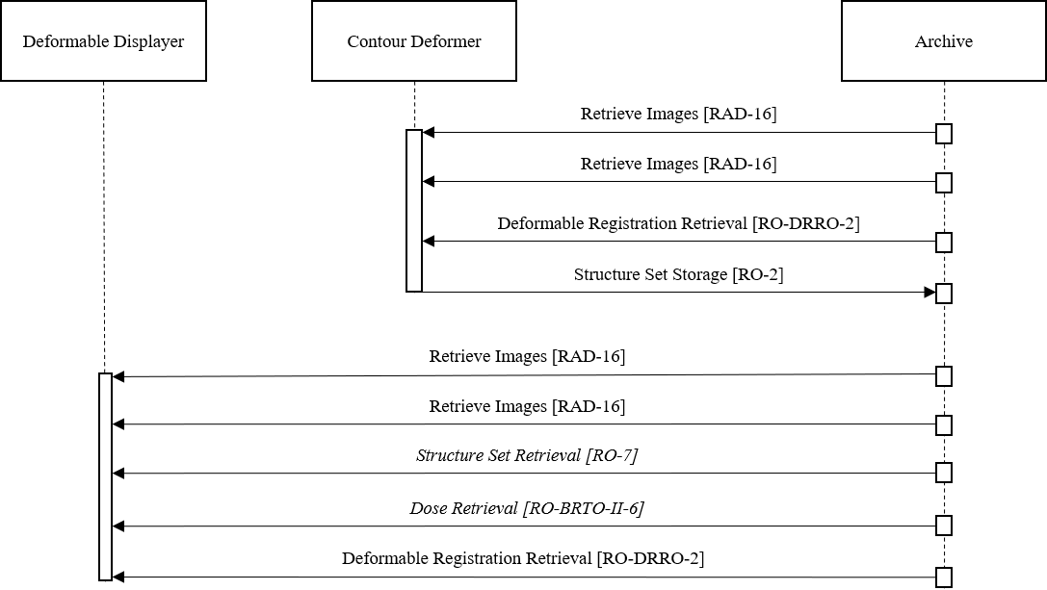
Figure X.4.2.2.2-1 Process Flow for Multimodality Contouring I

X.4.2.3 Use Case #3: Multimodality Contouring II
The deformable image registration is used to propagate structures between images in the system.

X.4.2.3.1 Multimodality Contouring II Use Case Description
- Received:
  - Two series of images as CT/MR/PET Image Objects – registered Image R and source Image S.
  - Structures (regions and points of interests) as RT Struct on Image R
  - A deformable image registration from Image R to Image S as Deformable Spatial Registration Object.
- Action: A Contour Deformer Actor allows propagation of the structures from Image R to Image S based on the deformable image registration.
- Stored: The structures in Image S are stored as a RT Struct Object.

X.4.2.3.2 Multimodality Contouring II Process Flow

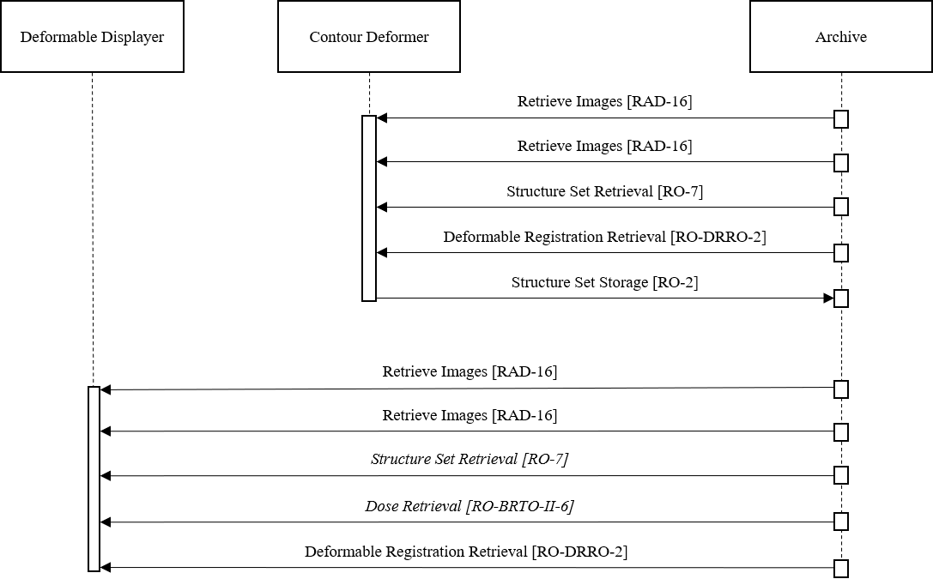
Figure X.4.2.3.2-1 Process Flow for Multimodality Contouring II

X.4.2.4 Use Case #4: Dose Deformation
The deformable image registration is used to map the dose from one image to another in the system.

X.4.2.4.1 Dose Deformation Use Case Description
- Received:
  - Two series of images as CT/MR/PET Image Objects – registered Image R and source Image S
  - A deformable image registration from Image R to Image S as Deformable Spatial Registration Object.
  - A dose on Image S as RT Dose Object.
- Action: A Dose Actor allows mapping of the dose on Image S to Image R based on the deformable image registration.
- Stored: The deformed dose is stored as a RT Dose Object in the frame-of-reference and patient orientation as Image R.

X.4.2.4.2 Dose Deformation Process Flow
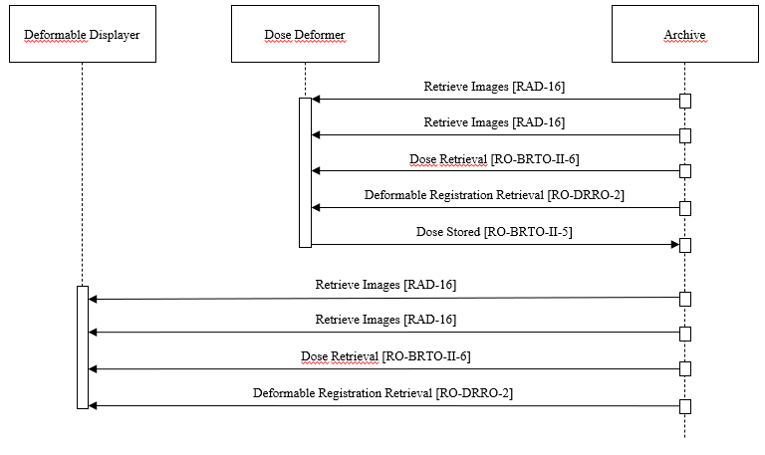
Figure X.4.2.4.2-1 Process Flow for Dose Deformation

X.4.2.5

Use Case #5: Image Deformation
The deformable image registration is used to deform an image in the system.

X.4.2.5.1 Image Deformation Use Case Description
- Received:
  - Two series of images as CT/MR/PET Image Objects – registered Image R and source Image S
  - A deformable image registration from Image R to Image S as Deformable Spatial Registration Object.
- Action: An Image Actor allows deforming Image R to Image S based on the deformable image registration.
- Stored: The deformed image is stored as a CT/MR/PET Image Object, where the geometrical information corresponds to Image R:
  - Image acquisition information corresponds to Image S.
  - Reference to Deformable Spatial Registration Object
  - Referenced Image (Image S)
  - Dates and time taken from Image S

X.4.2.5.2 Image Deformation Process Flow
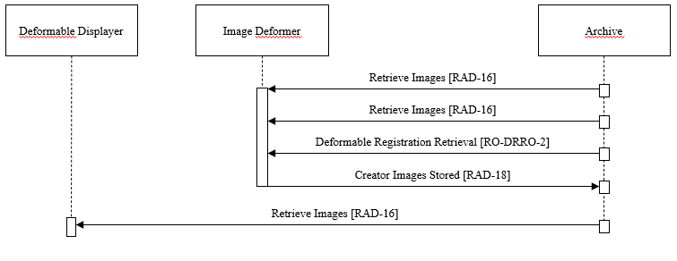
Figure X.4.2.5.2-1 Process Flow for Image Deformation

X.4.2.6

Use Case #6: Image Distortion Correction
The deformable image registration is used to deform an image in the system. Applicable, e.g., for phantom based geometrical correction of MRI images where a displacement field which may not be patient-specific is used.

X.4.2.6.1 Image Distortion Correction Use Case Description
- Received:
  - One series of images as CT/MR/PET Image Object – source Image S
  - A displacement field to Image S as Deformable Spatial Registration Object.
- Action: An Image Actor deforms Image S based on the displacement field.
- Stored: The deformed image is stored as a CT/MR/PET Image Object, where:
  - Image acquisition information corresponds to Image S.
  - Reference to Deformable Spatial Registration Object
  - Referenced Image (Image S)
  - Dates and time taken from Image S

X.4.2.6.2 Image Distortion Process Flow
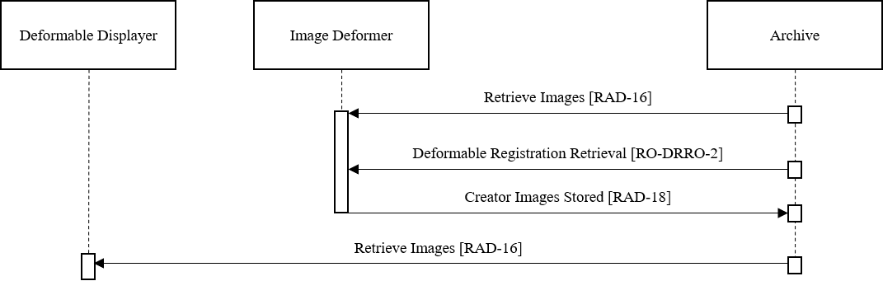
Figure X.4.2.6.2-1 Process Flow for Image Deformation

X.5 DRRO Security Considerations
There are no explicit security considerations in this profile.

X.6 DRRO Cross Profile Considerations
Consistent Presentation of Images (CPI) – Consistent Presentation of Images Integration Profile
Actors of the DRRO profile uses the Retrieve Images [RAD-16] and Creator Images Stored [RAD-18] transactions defined by the CPI profile (RAD TF-1: 5).

BRTO-II – Basic Radiation Therapy Objects Integration Profile II
A Contourer in BRTO-II might be grouped with a Deformed Contourer to support a rich suite of contouring tools.

MMRO-III - Multimodality Image Registration for Radiation Oncology 2018
A Registrator in MMRO-III might be grouped with a Deformable Registrator to support both spatial registration and deformable registration.
A Registered Display in MMRO-III might be grouped with a Deformable Displayer to support display of spatial registrations and deformable registrations.
A Registered Dose Display in MMRO-III might be grouped with a Deformable Displayer to support display of registered dose.
A Registered Contourer in MMRO-III might be grouped with a Deformable Contourer to support spatial registration of contours and deformable registration of contours.

Volume 2 – Transactions

3.X Deformable Registration Storage [RO-DRRO-1]

3.X.1 Scope

3.X.2 Actor Roles
Actor: | Deformable Registrator
Role: | Create and transmit Deformable Spatial Registration Objects

3.X.3 Referenced Standards
DICOM 2020d Edition PS 3.3

3.X.4 Messages

3.X.4.1 Storage of Deformable Registration

3.X.4.1.1 Trigger Events
The Deformable Registrator retrieves images (Images S and Images R) and creates a Deformable Spatial Registration instance.

3.X.4.1.2 Message Semantics
The following actions and transmissions are expected:
- Retrieve image series Images S
- Retrieve image series Images R
- Process images and create deformable registration
- Store deformable registration

The content of the deformable registration shall conform to the content module definition 7.3.11 Deformable Spatial Registration IOD in RO TF-3.

3.X.4.1.3 Expected Actions
The Deformable Registrator processes the image series Images S and Images R and creates a Deformable Spatial Registration instance.

3.Y Deformable Registration Retrieval [RO-DRRO-2]

3.Y.1 Scope

3.Y.2 Actor Roles
Actor: | Deformable Displayer
Role: | Retrieve Deformable Spatial Registration Objects For Display
Actor: | Contour Deformer
Role: | Retrieve Deformable Spatial Registration Objects To Deform Contours
Actor: | Image Deformer
Role: | Retrieve Deformable Spatial Registration Objects To Deform Images
Actor: | Dose Deformer
Role: | Retrieve Deformable Spatial Registration Objects To Deform Dose

3.Y.3 Referenced Standards
DICOM 2020d Edition PS 3.3

3.Y.4 Messages

3.Y.4.1 Retrieval of Deformable Registration

3.Y.4.1.1 Trigger Events
The Deformable Displayer retrieves Images (Images S, Images R), Structure Set (optional), Dose (optional), and a Deformable Spatial Registration instance.

3.Y.4.1.2 Message Semantics
The following actions and transmissions are expected:
- Retrieve image series Images S
- Retrieve image series Images R
- Retrieve Structure Set (optional)
- Retrieve Dose (optional)
- Retrieve Deformable Spatial Registration

3.Y.4.1.3 Expected Actions
The Deformable Displayed processes the image series Images S and Images R and Deformable Spatial Registration instance. Optionally it applies the registration on the retrieved structure set and dose.

Volume 3 – Content Modules

7.3 IOD Definitions

7.3.11 Deformable Spatial Registration IOD

7.3.11.1 Deformable Spatial Registration IOD for General Use

7.3.11.1.1 Deformable Spatial Registration IOD Base Content

7.3.11.1.2 Referenced Standards
DICOM 2020d PS 3.3

7.3.11.1.3 IOD Definition
IE | Module | Reference | Usage | IHE-RO Usage
Patient | Patient | C.7.1.1 | M | M
 | Clinical Trial Subject | C.7.1.3 | U | U
Study | General Study | C.7.2.1 | M | M
 | Patient Study | C.7.2.2 | U | U
 | Clinical Trial Study | C.7.2.3 | U | U
Series | General Series | C.7.3.1 | M | M
 | Clinical Trial Series | C.7.3.2 | U | U
 | Spatial Registration Series | C.20.1 | M | M
Frame of Reference | Frame of Reference | C.7.4.1 | M | R  See 7.4.1.7.1
Equipment | General Equipment | C.7.5.1 | M | M
 | Enhanced Frame of Reference | C.7.5.2 | M | M
Spatial Registration | Deformable Spatial Registration | C.20.3 | M | R  See 7.4.11.1
 | Common Instance Reference | C.12.2 | M | M
 | General Reference | C.12.4 | U | U
 | SOP Common | C.12.1 | M | M

7.4 Module Definitions

General Modules

7.4.1.7

Frame of Reference Module

7.4.1.7.1

Frame of Reference Module for Deformable Registrations

7.4.1.7.1.1 Reference Standards
DICOM 2020d Edition PS 3.3

7.4.1.7.1.2 Module Definition
Attribute | Tag | Type | Attribute Note
Frame of Reference UID | (0020,0052) | R | This should be used for Registered RCS.
Position Reference Indicator | (0020,1040) | -

7.4.1.8 General Image Module
This Module Content must be present for any instance of the following SOP Classes that is used in adherence to the Deformable Registration in Radiation Oncology profile:
- CT Image Storage (1.2.840.10008.5.1.4.1.1.2)
- MR Image Storage (1.2.840.10008.5.1.4.1.1.4)
- Positron Emission Tomography Image Storage (1.2.840.10008.5.1.4.1.1.128)

7.4.1.8.3 General Image Module in Deformed Image

7.4.1.8.3.1 Reference Standards
DICOM 2020d Edition PS 3.3

7.4.1.8.X.2 Module Definition
Attribute | Tag | Type | Attribute Note
Image Type | (0008,0008) | R | Shall be DERIVED\SECONDARY

7.4.1.9 General Reference Module
This Module Content must be present for any instance of the following SOP Classes that is used in adherence to the Deformable Registration in Radiation Oncology profile:

- CT Image Storage (1.2.840.10008.5.1.4.1.1.2)

- MR Image Storage (1.2.840.10008.5.1.4.1.1.4)

- Positron Emission Tomography Image Storage (1.2.840.10008.5.1.4.1.1.128
- )

7.4.1.9.1 General Reference Module in Deformed Image

7.4.1.9.1.1 Referenced Standards
DICOM 2020d Edition PS 3.3

7.4.1.9.1.2 Module Definition
Attribute | Tag | Type | Attribute Note
Derivation Description | (0008,2111) | R+ | Shall be present
Derivation Code Sequence | (0008,9215) | R+ | Shall be present
>Code Value | (0008,0100) | R+ | Shall be ‘125028’
>Code Scheme Designator | (0008,0102) | R+ | Shall be ‘DCM’
>Code Meaning | (0008,0104) | R+ | Shall be ‘Deformed for Registration’ or localized version
Source Instance Sequence | (0042,0013) | R+ | Shall be present
>Referenced SOP Class UID | (0008,1150) | R+ | Shall be ‘1.2.840.10008.5.1.4.1.1.66.3’ for Deformable Spatial Registration Storage
>Referenced SOP Instance UID | (0008,1155) | R+
>Purpose of Reference Code Sequence | (0040,A170) | R+ | Shall be present
>>Code Value | (0008,0100) | R+ | Shall be ‘125027’
>>Code Scheme Designator | (0008,0102) | R+ | Shall be ‘DCM’
>>Code Meaning | (0008,0104) | R+ | Shall be ‘Source Deformable Spatial Registration’

7.4.1.9.2 General Reference Module in Deformed Structure Set

7.4.1.9.2.1 Referenced Standards
DICOM 2020d Edition PS 3.3

7.4.1.9.2.2 Module Definition
Attribute | Tag | Type | Attribute Note
Derivation Description | (0008,2111) | R+ | Shall be present
Derivation Code Sequence | (0008,9215) | R+ | Shall be present
>Code Value | (0008,0100) | R+ | Shall be ‘125028’
>Code Scheme Designator | (0008,0102) | R+ | Shall be ‘DCM’
>Code Meaning | (0008,0104) | R+ | Shall be ‘Deformed for Registration’ or localized version
Source Instance Sequence | (0042,0013) | R+ | Shall be present
>Referenced SOP Class UID | (0008,1150) | R+ | Shall be ‘1.2.840.10008.5.1.4.1.1.66.3’ for Deformable Spatial Registration Storage
>Referenced SOP Instance UID | (0008,1155) | R+
>Purpose of Reference Code Sequence | (0040,A170) | R+ | Shall be present
>>Code Value | (0008,0100) | R+ | Shall be ‘125027’
>>Code Scheme Designator | (0008,0102) | R+ | Shall be ‘DCM’
>>Code Meaning | (0008,0104) | R+ | Shall be ‘Source Deformable Spatial Registration’

7.4.13 Dose-Related Modules

7.4.13.3 RT Dose Module

7.4.13.3.2 RT Dose in Deformed Dose
This Module Content must be present for any instance of the following SOP Classes that is used in adherence to the Deformable Registration in Radiation Oncology profile:
- RT Dose Storage (1.2.840.10008.5.1.4.1.1.481.2
- )

The following table lists redefinitions of attributes within the Deformable Registration in Radiation Oncology, which extend the definitions of RT Dose Module Base Content.

7.4.13.3.2.1 Reference Standards
DICOM 2020d Edition PS 3.3

7.4.13.3.2.2 Module Definition
Attribute | Tag | Type | Attribute Note
Dose Type | (3004,0004) | R | Shall be the same as the original dose.
Spatial Transform of Dose | (3004,0005) | R+ | Shall be NON_RIGID.
Referenced Spatial Registration Sequence | (0070,0404) | R+ | Shall reference the Deformable Spatial Registration SOP Instance used to deform the dose.
Start Include Table 10-11 “SOP Instance Reference Macro Attributes”
>Referenced SOP Class UID | (0008,1150) | R+ | Shall be ‘1.2.840.10008.5.1.4.1.1.66.3’ for Deformable Spatial Registration Storage
>Referenced SOP Instance UID | (0008,1155) | R+
End Include Table 10-11 “SOP Instance Reference Macro Attributes”

7.4.15 Deformable Spatial Registration Modules in Planning

7.4.15.1 Deformable Spatial Registration Module

7.4.15.1.1 Deformable Spatial Registration Module Base Content

7.4.15.1.1.1 Referenced Standards
DICOM 2020a Edition PS 3.3

7.4.15.1.1.2 Module Definition
Attribute | Tag | Type | Attribute Note
Content Date | (0008,0023) | -
Content Time | (0008,0033) | -
Start Include of Table 10-12 “Content Identification Macro Attributes”
Instance Number | (0020,0013) | -
Content Label | (0070,0080) | R+ | Label used to distinguish registration instances. Shall not be empty
Content Description | (0070,0081) | R+ | Description used to distinguish registration instances. Shall not be empty.
End Include of Table 10-12 “Content Identification Macro Attributes”
Deformable Registration Sequence | (0064,0002) | R+* | Exactly two Item shall be present. One Item shall represent the Registered Image (with no Deformable registration grid sequence). The other Item shall represent the Source Image and shall have a Deformable Registration Grid Sequence
>Source Frame of Reference UID | (0064,0003) | - | Identities a Frame of Reference that may or may not be an image set. Shall be present.
>Referenced Image Sequence | (0008,1140) | O+* | Shall be Empty or shall include one Item within the specified Source Frame of Reference UID (0064,0003)
>>Include 'Image SOP Instance Reference Macro' Table 10-3
>Frame of Reference Transformation Comment | (3006,00C8) | -
>Registration Type Code Sequence | (0070,030D) | R+ | Shall be present and include one of the items in CID 7100 RCS Registration Method Type.
>Code Value | (0008,0100) | R+* | Shall be one of ‘125022’, ‘125024’ or ‘125026’
>Code Scheme Designator | (0008,0102) | R+* | Shall be ‘DCM’
>Code Meaning | (0008,0104) | R+* | Shall be the Code Meaning corresponding to the value in Code Value (0008,0010) as specified in CID 7100
>Pre Deformation Matrix Registration Sequence | (0064,000F) | RC+ | Shall include one Item for the Source Image in case a matrix transformation needs to be applied prior to deformation. In case this Item is absent the identity transformation matrix shall be applied.  Shall be absent for the Registered Image
>>Frame of Reference Transformation Matrix | (3006,00C6) | -
>>Frame of Reference Transformation Matrix Type | (0070,030C) | R+ | Shall be RIGID
>Post Deformation Matrix Registration Sequence | (0064,0010) | X | Shall not be present
>Deformable Registration Grid Sequence | (0064,0005) | RC+ | Shall be present for Source Image and shall be absent for Registered Image.
>>Image Orientation (Patient) | (0020,0037) | R
>>Image Position (Patient) | (0020,0032) | R
>>Grid Dimensions | (0064,0007) | R
>>Grid Resolution | (0064,0008) | R
>>Vector Grid Data | (0064,0009) | R*
>Used Fiducials Sequence | (0070,0314) | -

